**MESD Documentation LMS-111-Customize-Moodle-Theme**

**Purpose**

To allow for the look and feel to be enhanced.

**Background**

The MESD LMS will be hosted and housed by the 1Gov 1Citizen platform. This initiative exists to provide services to provide residents of Botswana in a more efficient and effective manner. The MESD LMS will be a service that will be available through this portal and thus it will need to have an appealing User interface and experience.

**How it works?**

The look and feel is customized by making use of a theme plugin in moodle. 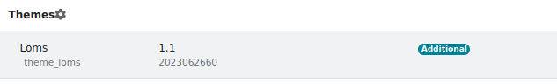

Ensure the Loms plugin is installed from Site Administration -> Plugins -> Plugins Overview